Website Design Made Simple

Steps to getting started:
- Type in the address bar: www.wix.com

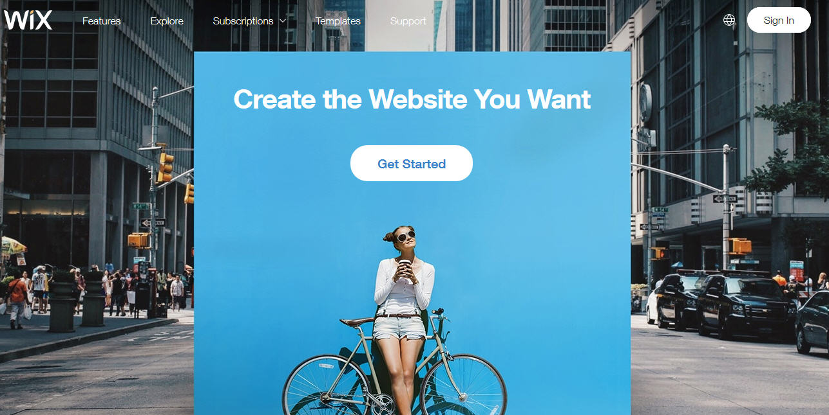

- You will need to create an account if you do not have one. All you have to do is sign up or log-in if you already have an account:

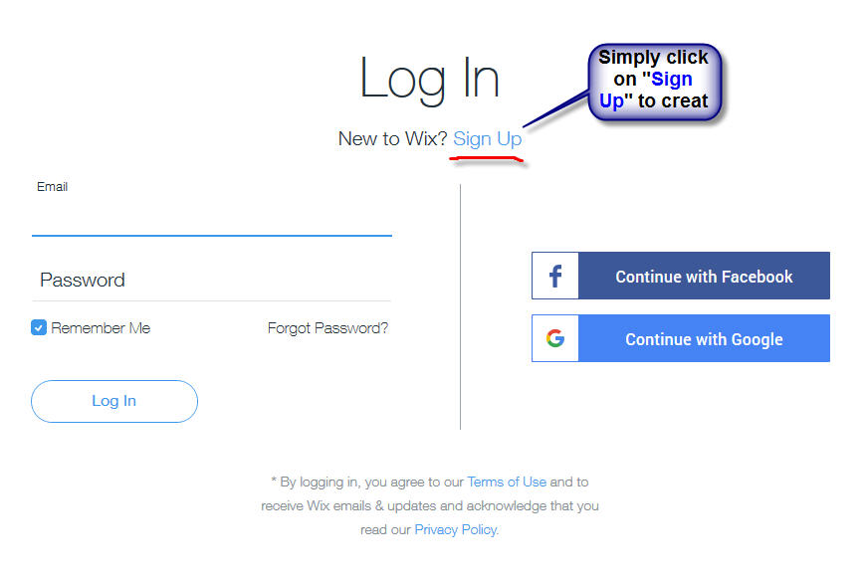

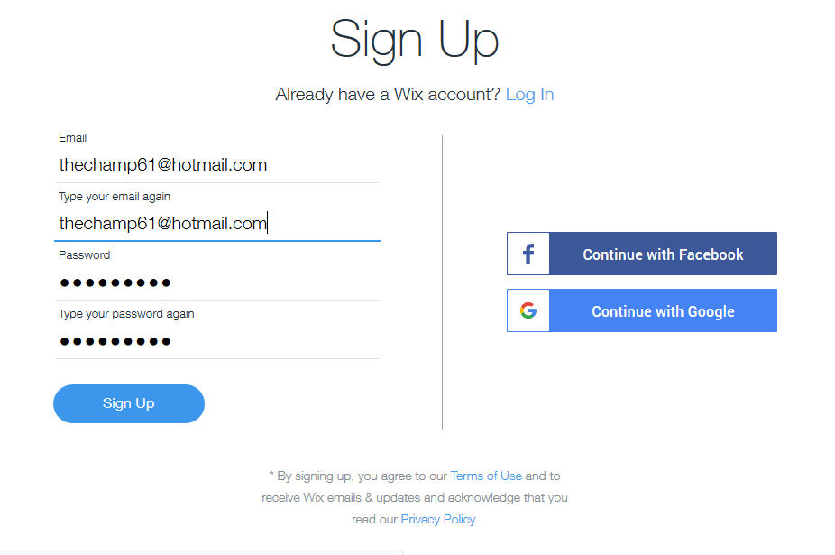

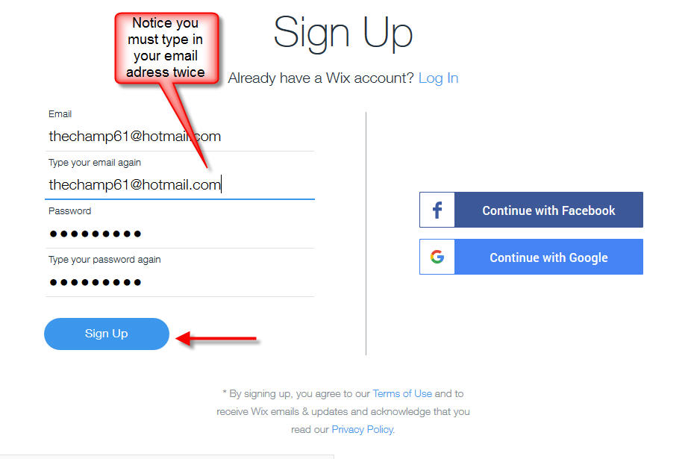
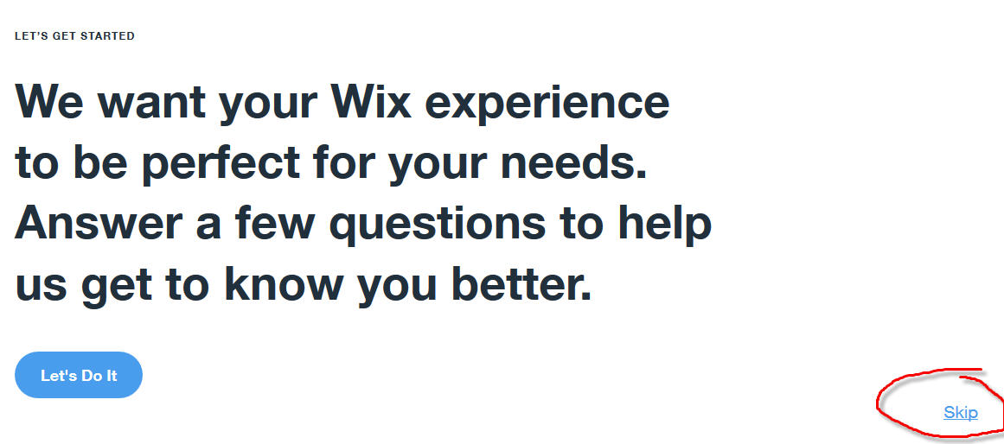

- You can decide if you want to answer the questions or just simply skip them. Some of the questions are looking to understand what type of website you are interested in creating. We are going to select “Choose a Template” so that we can create our own.

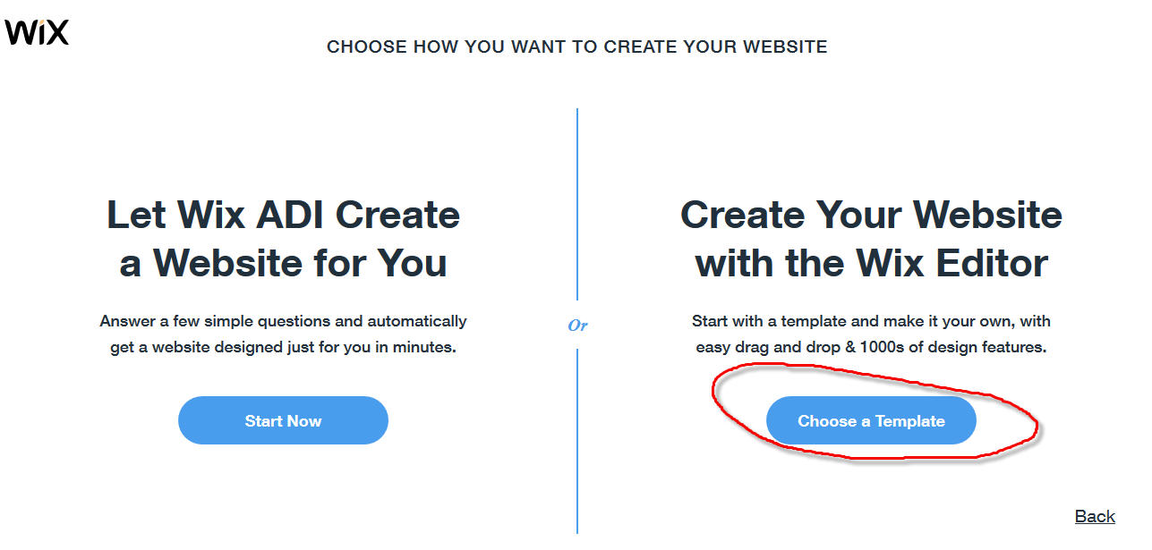

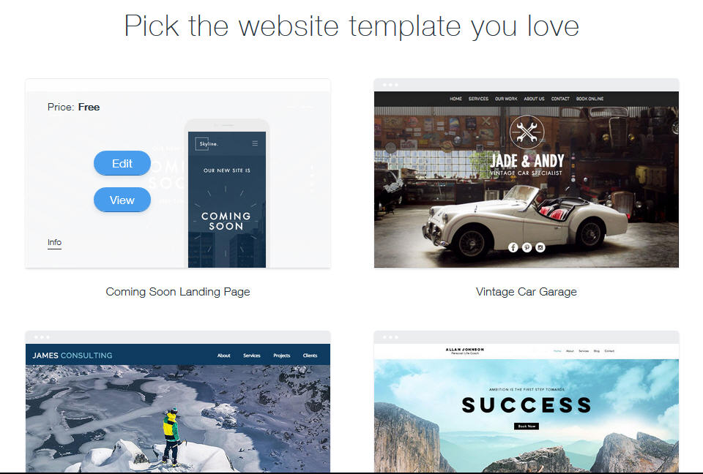

- There are so many FREE templates to choose from to create an awesome website just for you. There are so many templates to choose from. Just take your time. To further help you with your website project there are instructional or tutorial videos to make it so simple.
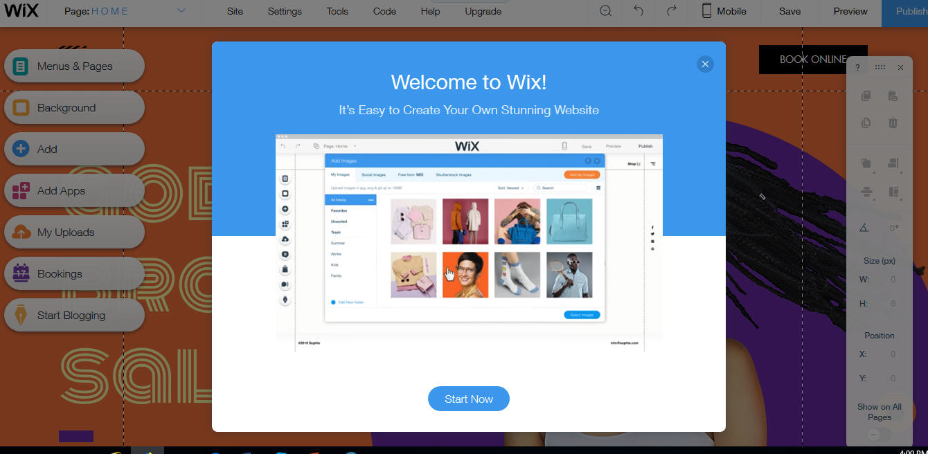

- Once you select a template you can edit the name, the sections, and the pages to fit your taste. If you need more assurance simply review one of the following videos:

- Wix tutorial step-by-step videos. Under ‘HELP’ in the Wix tool bar you will find ‘Step-by-Step’ videos to help you.

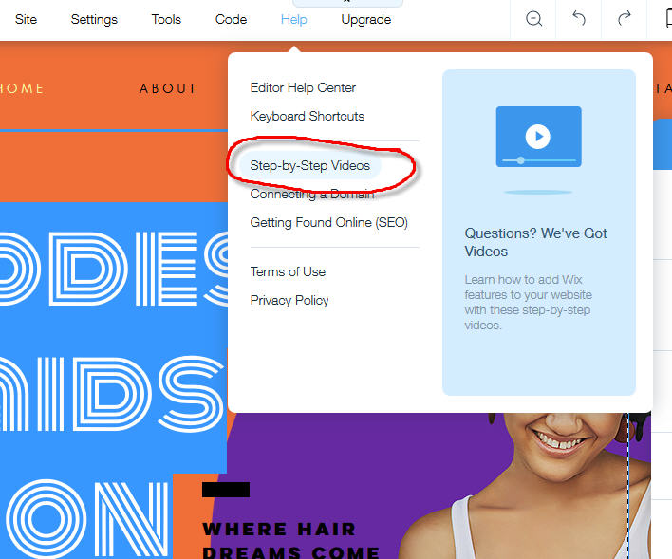

- You can also make use of WWW.YouTube.com. One video that is really short and sweet is at: https://youtu.be/gi7dTKse9Tg

