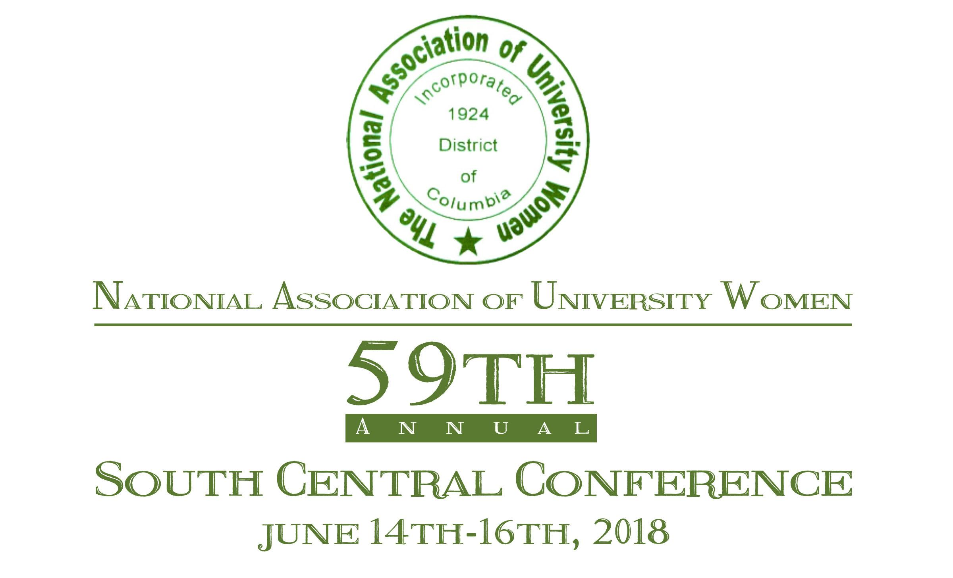
EMBASSY SUITES by Hilton Hotel
11301 Financial Centre Pkwy
Little Rock, AR 72211

Host Branches
Little Rock Arkansas & Little Rock Metro Area
Officers
Evelyn Wright, National President
Dr. Debra J. Yarbrough, South Central Sectional Director
Betty W. Wilkerson, South Central Coordinator
Branch Presidents
Little Rock Arkansas - Kathryn Buril
Little Rock Metro Area - Kristin Knox

Evelyn Wright, National President
Dr. Debra J. Yarbrough, South Central Sectional Director
Hosted by Little Rock Arkansas and Little Rock Metro Branches
Kathryn Buril and Kristin Knox, Branch Presidents
REGISTRATION FORM (PLEASE PRINT OR TYPE)
Last Name_____________________ First _____________________M.I._______
Address_______________________________________________________Apt./Unit#_________
City__________________________ State_____ Zip Code_______ Phone (___) ______________
Email _________________________________ Branch __________________________________
Emergency Contact: Name________________________________ Phone (___) _______________
Branch Name/President’s Name ______________________________________________________________________________
REGISTRATION STATUS (CHECK ONE)
___ Delegate ___Alternate ___ Member (non-delegate) ___ South Central Sectional Officer
___ Committee Chair ___National Officer ___ First Time Attendee
REGISTRATION FEES
_____$155.00 (Postmarked by April 14th, 2018) Early Bird Special $ ______________________
_____$165.00 (Postmarked by May 15th, 2018) On time $ ______________________
_____$185.00 (Late/On-site registration; cash/ money order only) $ ______________________
_____$35.00 (Additional Luncheon ticket, Saturday June 16th, 2018) $ ______________________
Total Amount Enclosed $ ______________________
Note: Branch checks/money orders are payable to South Central Sectional Conference

Please return to:
NAUW South Central Sectional Conference
Post Office Box 56351
Little Rock, Arkansas 72215

EMBASSY SUITES by Hilton Hotel
June 14th-16th, 2018
11301 Financial Centre Pkwy
Little Rock, AR 72211
Reservations: 501-312-9000
Your Hilton Link is: http://embassysuites.hilton.com/en/es/groups/personalized/L/LITCPES-AUW-20180613/index.jhtml
Make yourself at home in one of the 251 air-conditioned rooms featuring refrigerators and microwaves. Flat-screen televisions with cable programming are provided for your entertainment, with wired and wireless Internet access available for a surcharge. Private bathrooms with showers feature complimentary toiletries and hair dryers. Conveniences include phones, as well as desks and complimentary weekday newspapers. For a more formal setting, you will find delicious cuisines such as: The Butcher Shop Steakhouse, Copelands, Bravo Cucina Italian, and YaYa’s Euro Bistro. For more casual dining out: Texas Roadhouse, BJ’s Restaurant & Brewhouse, Chuy’s, Pei Wei are also in close proximity.
*******************************************************************************
Please use link above for reservations:
NAME ______________________________ ADDRESS _______________________________________________
CITY __________________________ STATE ______ ZIP CODE________ PHONE (___) __________________
ARRIVAL _______________________ DEPARTURE ______________________
NAME(S) OF PERSON(S) SHARING ROOM ______________________________________________________________________________
LIST PHYSICAL RESTRICTIONS _________________________________________________________________
CANCELLATION CUT OFF TIME WITHOUT LOSS OF DEPOSIT: UP to 48 hours PRIOR to ARRIVAL
PLEASE CHECK ROOM TYPE REQUESTED:
______2 Double Beds $119.00 1 person; $129.00 2 persons; $139.00 3 persons; $149.00 4 persons
______ King Basic $119.00 1 person; $129.00 2 persons; $139.00 3 persons; $149.00 4 persons
Note: King Executive Suite is not available
Cut-off Date- May 15, 2018 Reservation received after this date will be taken based on availability.
ROOMS NOT AVAILABLE FOR CHECK-IN UNTIL 4:00 P.M.
CHECK-OUT TIME IS 11:00 a.m.

59th SOUTH CENTRAL SECTIONAL CONFERENCE JUNE 14th-16th, 2018
Evelyn Wright, National President
Dr. Debra J. Yarbrough, South Central Sectional Director
Hosted by Little Rock Arkansas and Little Rock Metro Area Branches
Kathryn Buril and Kristin Knox, Branch Presidents

TENTATIVE AGENDA AND ACTIVITY SCHEDULE
Thursday, June 14th, 2018
Attire: Business Casual
2:00 p.m. - 7:00 p.m...……………………….………………...………..….……………………......Registration
4:00 p.mp - 6:00 p.m. ………………………………………………...…….South Central Executive Meeting
(Sectional Officers, Branch Presidents, Sectional Committee Chairs, Consultants and National Officers)
Reception - Shades of Purple (Dressy/Semi - Formal)
7:00 p.m. - 10:00 p.m.…....………………………………………………………………....……….....Reception

Friday, June 15th, 2018
Attire: White
7:00 a.m. - 6:00 p.m.………………...…………….……………………………………………….... Registration
7:00 a.m. - 9:00 a.m. ……………………………….…………………………..… Breakfast (Provided at Hotel)
8:00 a.m.– 9:00 p.m……..………………………………...……………………………...……....………Vendors
8:15 a.m. - 12:00 noon ………....……………………………...……. 1st Plenary Session & Parade of Branches
(7:45 a.m. –Line up– Branch Presidents, Sectional Officers, Sectional Director, Forever Emeralds, and National Officers)

Workshops (I, II, and III)
12:00 noon– 1:15 p.m...……………….………………………………………….…….…Lunch (On Your Own)
1:20 p.m.– 3:45 p.m.…...………………………………………..............2nd Plenary Session/Memorial Service
4:00 p.m.………….....…………………………………………………..……..….…....……Conference Pictures
Attire: Pink (Dressy/Semi-Formal)
7:00 p.m. –10:00 p.m. …...……………………….……………………...…..…..….. Public Program/ Reception

Saturday, June 16th, 2018
Luncheon Attire: White, Green & White or Green
7:00 a.m. - 12:00 noon.…….…….………………....………..……………………………………….Registration
7:00 a.m. – 8:00a.m.……………………………………...……………..………... Breakfast (Provided at Hotel)
8:00 a.m.– 2:00 p.m. ………...…..……………………………..…….…………..…………...……….....Vendors
8:00 a.m.– 11:00 a.m.……………………………………………….....………………...........3rd Plenary Session
11 a.m.……….………………...……………..……………….…………….…..………..Break/Check Out Time
12:00 noon …………...………………………………………….……………....………..........Award Luncheon

NATIONAL OFFICERS:
National President:
Evelyn L. Wright

National 1st Vice President:
Christiana Worthams

National 2nd Vice President:
Letisa Vereen

National Recording Secretary:
Annette Burtin

National Corresponding Secretary:
Jacqueline Green

National Financial Secretary:
Renetta English

National Treasurer:
Joyce Bryant

SECTIONAL OFFICERS:

Sectional Director:
Dr. Debra J. Yarbrough

Lay Member:
Stephanie Spikes

Corresponding Secretary:
Quintella Baskerville

Recording Secretary:
Dionne Frost

Financial Secretary:
Laura Levy

Treasurer:
Amanda Johnson

Nominating Chairperson:
Denise Antoine

Treasurer:
Amanda Johnson

Consultant:
Dr. Ezora Proctor

Consultant:
Ollie D. Johnson

NAUW National Headquarters
1001 E Street SE
Washington, DC 20003

Phone: 202-547-3967
Fax: 202-547-5226
Email: info@NAUW1910.org
Website: www.NAUW1910.org

A Public Service Organization
Deadline for 59th SCS Conference Souvenir Booklet Ads is March 23, 2018.

Dear Patron,

We, the Little Rock Arkansas and Little Rock Metro Area Branches of the National Association of University Women, have the esteemed pleasure of hosting this year’s South Central Sectional Conference. The theme for the occasion is “Progressive Women Remaining Relevant in a Global Society.” This theme will commemorate the organization’s 59th Sectional celebration. The three day conference will include dynamic speakers, empowering workshops and personal development training. An open reception will highlight talented youth throughout the Central Arkansas area along with dinner and special entertainment for your enjoyment.
The event will take place Friday, June 15, 2018 at the Embassy Suites Hotel 11301 Financial Centre Pkwy, Little Rock, AR.
The NAUW 59th South Central Sectional Conference Souvenir Booklet will serve as a memento of this historic event and enable us to:
- highlight the contributions and achievements of our branches to central Arkansas and surrounding communities;
- increase awareness of our organization and scholarship offerings and
- offer organizations, businesses and individuals, an opportunity to be recognized for their contribution and support to the communities of Central Arkansas.

The members of the Little Rock Arkansas and Little Rock Metro Area Branches have invited our family members, friends, and community leaders to l attend this prestigious event that will help commemorate the inception of the organization and the milestones that have been achieved. The commemorative souvenir book will serve as a reference to your business/organization and other organizations who supported this endeavor.

The Souvenir Book Ad form is enclosed indicating the cost of the various ad sizes. The ad must be camera ready. We have also included a history fact sheet for your perusal. Ads will not be returned. If you have questions about the Souvenir Journal, please contact Tanya Bell-Brooks at 501.313.2678.

Thank you in advance for your time and consideration. We look forward to hearing from you soon.

Sincerely,

Kathryn Buril Kristin Knox
Kathryn Buril Kristin Knox
Little Rock Arkansas Branch, President Little Rock Metro Area Branch, President

Delta Sigma Theta Sorority, Inc. was founded in 1913 on the campus of Howard University to promote academic excellence; to provide scholarships; to provide support to the underserved; to educate and stimulate participation in the establishment of positive public policy; and to highlight issues and provide solutions for problems in communities. Today, Delta Sigma Theta Sorority has more than 900 chapters worldwide and has initiated over 250,000 members. The Sorority uses its Five-Point Programmatic Thrust of economic development, educational development, international awareness and involvement, physical and mental health, and political awareness and involvement to create its national programs.

National Association of University Women
59th South Central Sectional Conference
Post Office Box 56351
Little Rock, Arkansas 72215

National Association of University Women
59th South Central Sectional Conference
Post Office Box 56351
Little Rock, Arkansas 72215

59th South central sectional conference Souvenir Book Ad Solicitation Form

The commemorative souvenir book will be distributed to more than 300 guests during the 59th South Central Sectional Conference Weekend to be held in Little Rock, Arkansas as well as to other branches, organizations, businesses, supporters, and community leaders.

Company/Organization Name:
Contact Person:
Address:
City/State: Zip Code:
Phone: Email:

Select Sponsorship Level:
___ Yes, I would like to purchase an advertisement (See Advisement Sheet)
___ Yes, I am enclosing a monetary donation $_________ donation amount

Advertising Rates: The booklet will be 8 1/2” by 11” Very elegant Color/Black and White Journal
Please check all that apply:
___ Outside Back Cover $300 ___ Inside Back Cover $250
___ Full Page $100 ___ One-Eighth Page $20
___ Half Page $70 ___ Business Card $15
___ Quarter Page $35 ___ Patron Listing $10
…………………………………………………………….

___ Camera – ready copy enclosed sent via e-mail to: tbellbrooks@yahoo.com
___ Business card enclosed or sent via e-mail to: tbellbrooks@yahoo.com
___ Ad copy has been sent via email with check as stated above.
Amount enclosed for Commemorative Souvenir Book Advertising $
Please note that ad copy and photos will not be returned

Mail ad submissions and monies to:
National Association of University Women
59th South Central Sectional Conference
P. O. Box 56351
Little Rock, Arkansas 72215
Thank you for your patronage. No ads will be printed without receipt of the corresponding fee in full.
Ad Submissions due no later than close of business on or before march 23, 2018
A Public Service Organization
National Association of University Women
59th South Central Sectional Conference
Post Office Box 56351
Little Rock, Arkansas 72215
